Assignment 2

Zendesk is a popular all-in-one customer service platform. A broad range of businesses from massive organizations to small startups uses this robust cloud-based help desk software. By providing organizations with a reliable support, the Zendesk support software assists them to succeed in self-service and proactive engagement. As it is designed for various types of users, you can utilize the Zendesk features no matter of what your business is, whether it is for SMBs, retailers, HR teams, enterprises, educations, and IT teams.

The help desk ticketing system serves as a centralized hub for all your conversations, resolve issues efficiently by gathering the right information from the customers, gain insights and allows you to take your customer service system apart from your competitors.

Zendesk Support – A platform for handling customer support operations and offers support by email, mobile, social media and voice with complete data reporting and 90+ integrations.

Zendesk Chat – A platform that offers live chat solution and support businesses to increase sales conversation through engaging leads on their websites.

Zendesk Explore – A platform that offers instant access to customer and business analytics to measure and boost the entire customer service

Zendesk Guide – A knowledge base that supports your customers to tap into your institutional knowledge and bring into play

Zendesk Talk – Call center software offers more personal phone support and enhances enterprise productivity

Zendesk Connect- Customer communication management software manages communications across channels and delivers better customer experiences

* Adding a live chat to your website

From the dashboard, select Settings > Widget, then click the Getting Started tab.

Copy the embed script, as shown in the example below:

In the source code of the web page, paste the embed script between the page's head tags.

You can paste it either right after the opening <head> tag or right before the closing </head>.

If you are concerned about page load performance, we recommend placing the snippet at the end of the <body> rather than the <head>. Even though the snippet script is very lightweight, it’s best to avoid inserting scripts that will block the browser from continuing to render a web page until that script has loaded. Just keep in mind that any scripts that use the Web Widget zE JavaScript API must be placed after the snippet script.

Save and publish the page.

The widget should be visible after reloading the page in a browser.

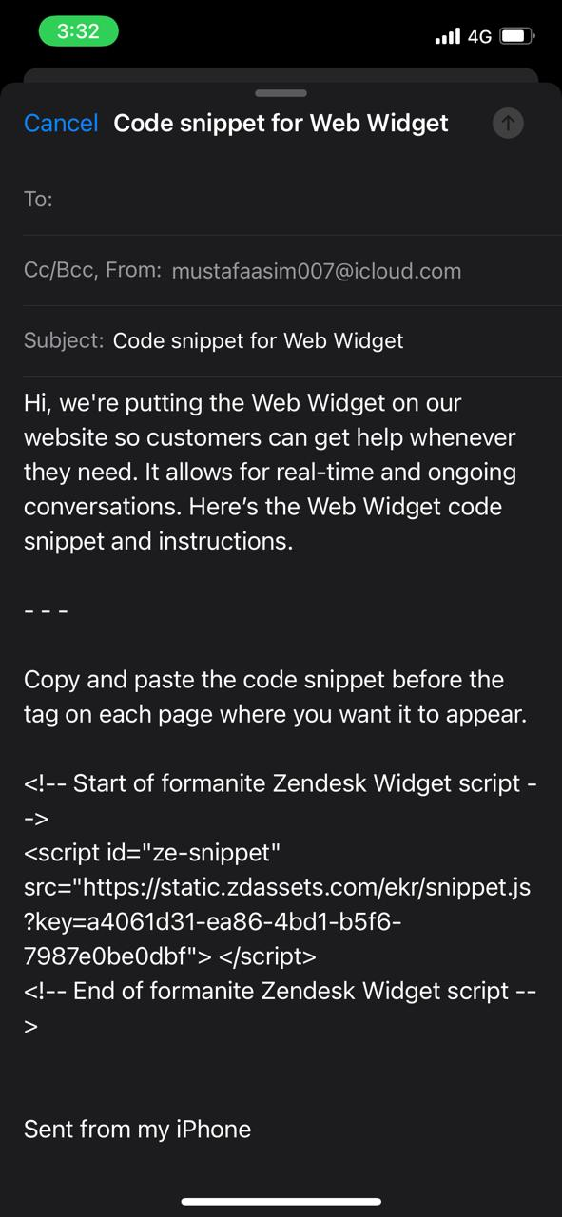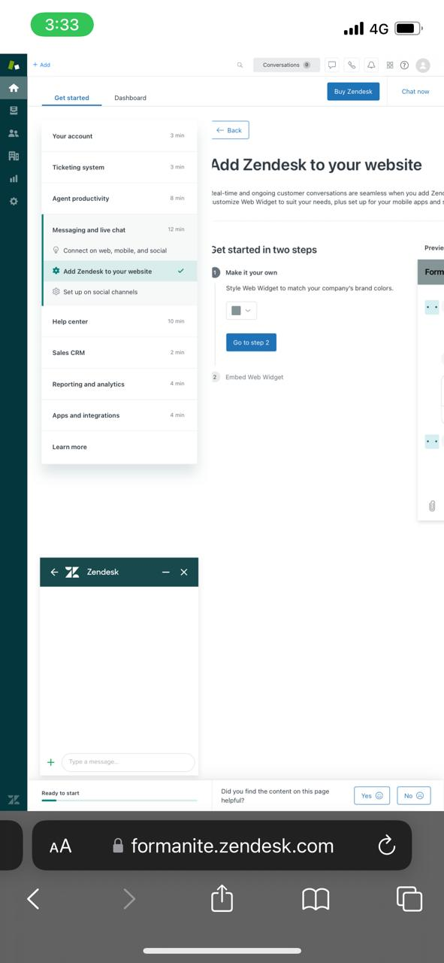

* Adding agent and admin on zendesk:

In Admin Center, click People in the sidebar, then select Team > Team members.

The Team members page opens.

Click Add team member.

Enter the team member’s Name and Email, then click Next.

In the Assign role section, select the user’s Support role from the Support drop-down list.

You set only the Support role now. You can set other roles later.

Click Save.

The new user is saved and receives a welcome email and link to sign in.

(Optional) Open the user's profile that appears at the top of the list on the Team members page to set any additional roles 